

www.villageofgreenisland.com/village/recycling

GLASS, METAL, & PLASTIC
INCLUDE |  | SPECIAL INSTRUCTIONS | DO NOT INCLUDE
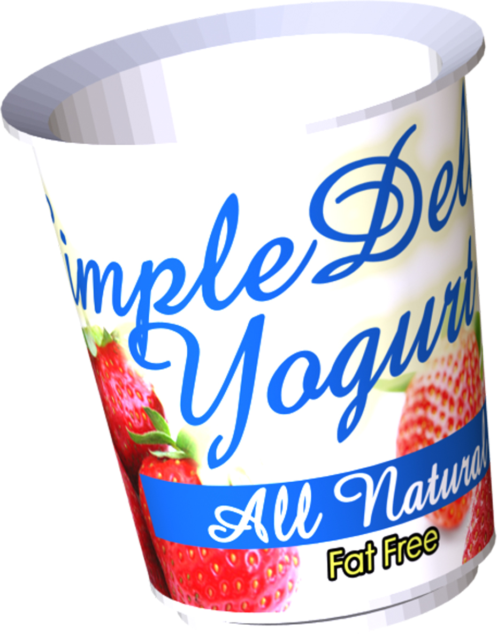  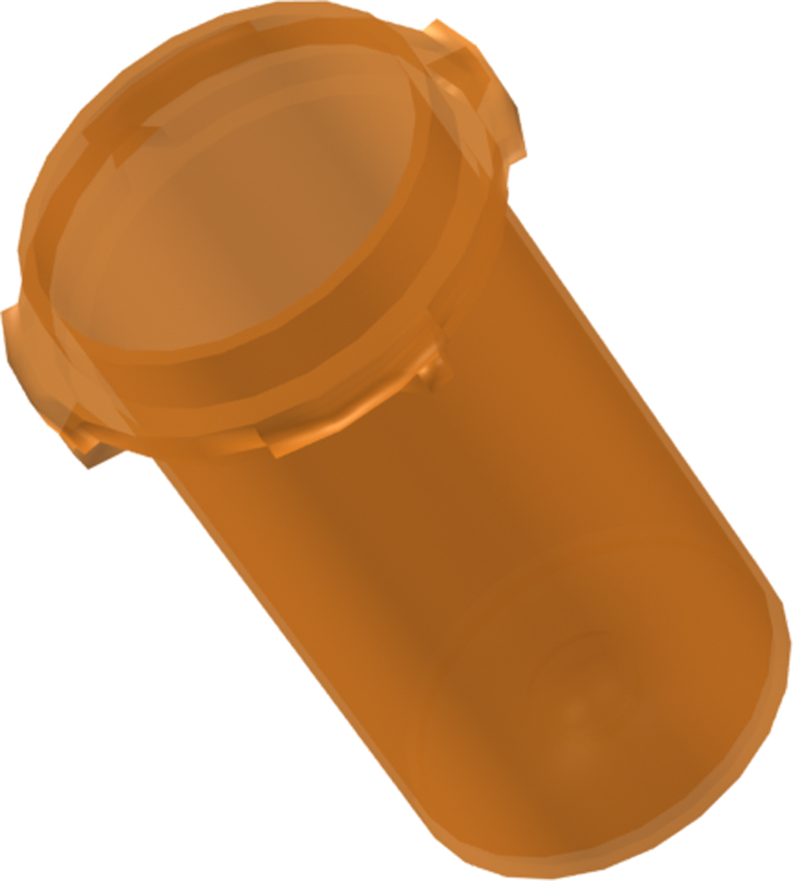  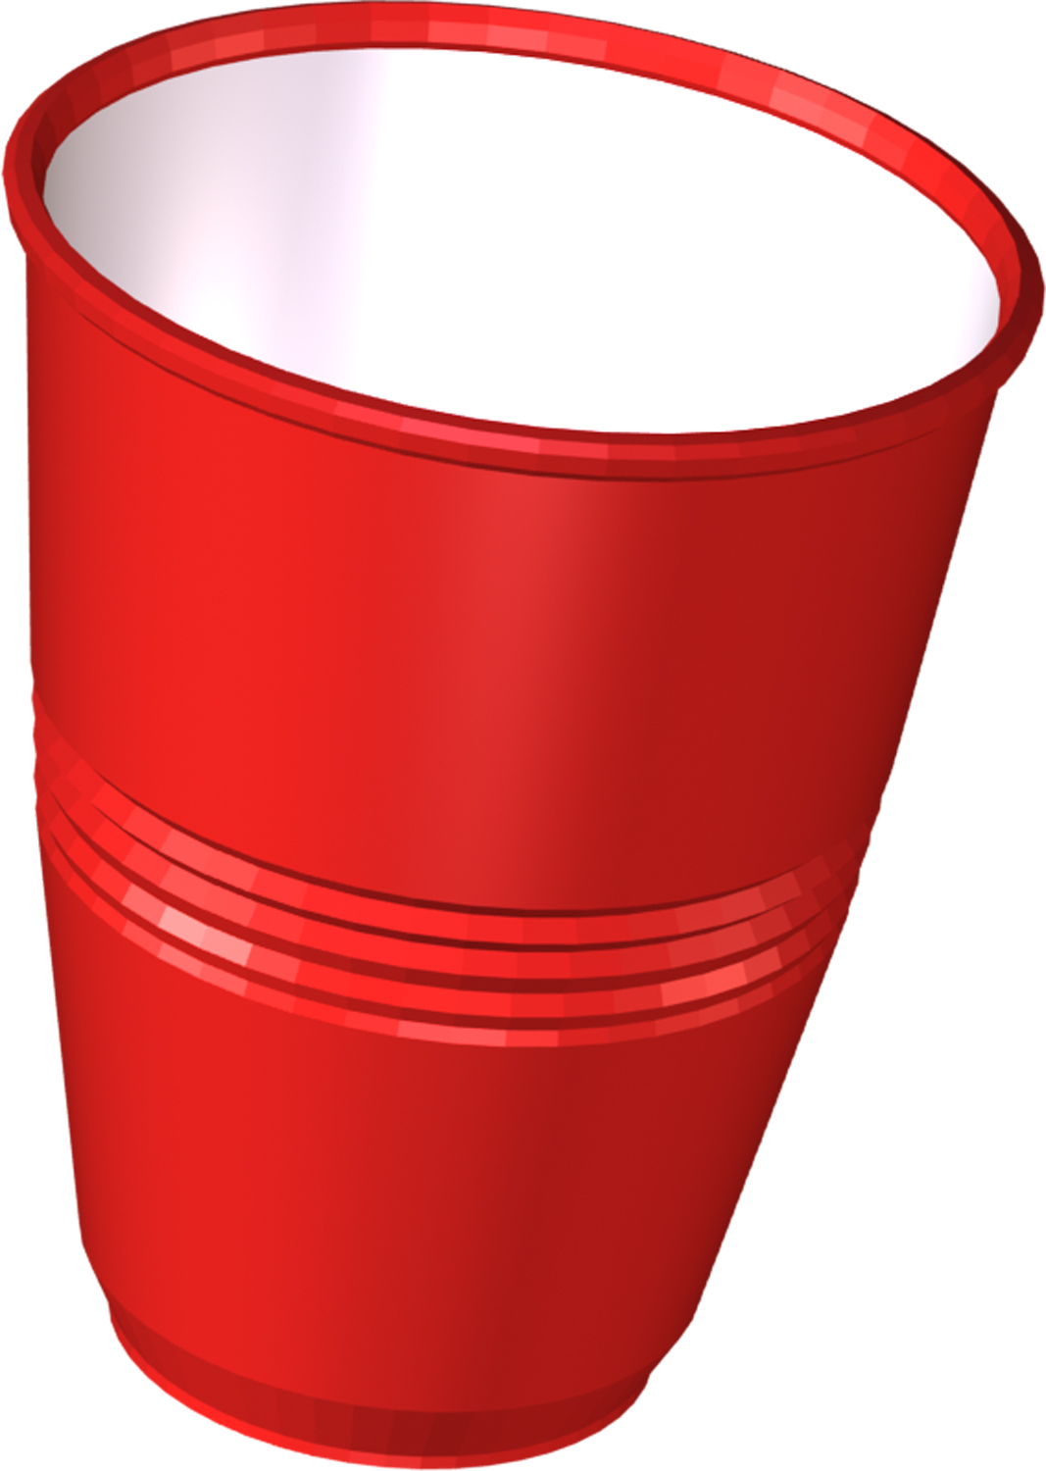  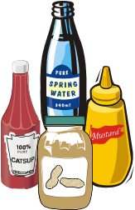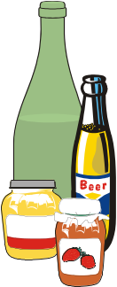 | - GLASS CONTAINERS- GREEN, BLUE, BROWN, & CLEAR  - Food & Beverage Containers  - Liquor & Wine Bottles  - Deposit Bottles  - Canning & Food Jars  - PLASTIC CONTAINERS- CODES 1 thru 7  - Soda Bottles  - Milk & Water Jugs  - Windshield Washer Jugs  - Mustard & Ketchup Bottles  - Food Containers  - Beverage Containers  - Butter & Yogurt Containers  - Prescription Pill Bottles  - Soap & Detergent Bottles  - Mouthwash Bottles  - Plastic Drinking Cups  - Salad Dressing Bottles  - Peanut Butter Jars  - Flower Pots & Containers  - Plastic Cat Litter Containers | Recyclables are picked up on regular trash pick-up days. All recyclables can be combined and placed in a clear plastic bag next to green refuse barrels.  Do not break glass  Broken Glass must be wrapped and secured and placed in trash  Labels do not need to be removed  Rinse thoroughly  ACCEPTABLE PLASTICS  (See code on bottom of containers)   | Broken Glass  Drinking Glass  Ovenware & Ceramics  Window Panes  Mirrors  Windshields  Mercury Filled Light Bulbs (i.e. fluorescent & CFL’s)  Dishes, Cups or Plates  Empty Plastic Bags  Plates & Tableware  Motor Oil Bottles  Clothes Hangers  Styrofoam Packaging  Furniture  Needles & Syringes  Six Pack Holders  Snack Bags  Toys  Plastic Caps & Lids  Plexiglass  CO2 & Smoke detectors  Thermostats
 | - BEVERAGE CARTONS  - Milk Cartons  - Juice Cartons  - Juice Boxes | Squeeze juice boxes until empty  Throw away straws | Straws & Wrappers  Plastic Caps
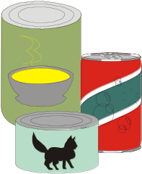 | - METAL & ALUMINUM  - Food & Beverage Cans  - Deposit Cans | Include metal lids  No need to flatten | Metal – Cardboard Containers (i.e. Cocoa)  Foil wrap or trays  Silverware  Small Appliances  (i.e. toasters, blenders)  Pesticides, chemicals gasoline & paint

PAPER & CARDBOARD
INCLUDE |  | SPECIAL INSTRUCTIONS | DO NOT INCLUDE
  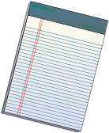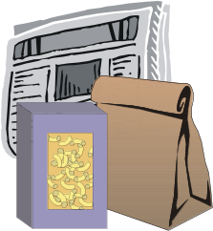 | - NEWSPAPERS & INSERTS  - MAGAZINES  - PHONE BOOKS  - BROWN GROCERY BAGS  - PAPERBACK BOOKS  - LIGHTWEIGHT CARDBOARD:  - DRY FOOD BOXES- CEREAL, COOKIE, SNACK…  - NON-FOOD BOXES- HEALTH CARE, GIFT…  - TOILET & PAPER TOWEL TUBES  - PAPERBOARD EGG CARTONS  - JUNK MAIL:  - CARDS & ENVELOPES  - LETTERS & ENCLOSURES  - PAPER:  - SCHOOL PAPERS  - COLORED PAPER  - COMPUTER PAPER  - SHREDDED PAPER  - CORRUGATED CARDBOARD | Most paper and cardboard can be flattened and placed in clear plastic bags with other single- stream recyclables.  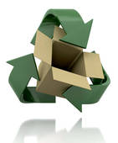  Large, bulky cardboard should be broken down and tied in bundles no larger than 3 feet by 2 feet. | Diapers  Napkins  Wax Paper  Tissues  Paper Plates  Tissue Paper  Paper Towels  Frozen Food Boxes  Microwave Containers  Pizza Boxes  Chips/Pretzel Bags  Plastic Wrappings  Carbon Paper  Construction Paper  Copier Paper Wrappers  Wax- Coated  Cardboard

YARDWASTE
INCLUDE |  | SPECIAL INSTRUCTIONS |  | DO NOT INCLUDE
 | - GRASS CLIPPINGS  - LEAVES  - BRANCHES  - BUSHES  - CHRISTMAS TREES  **Bulk Item Removal**  Items not allowed to be disposed of or recycled are picked up the1st & 3rd Thursday of every month  for a fee.  Visit www.villageofgreenisland.com/village/recycling for a list of items and prices.  *Extra fees may apply to heavy items.  **Prices subject to change due to market conditions.  ***Call the Village Office for items not listed  @ 518-273-2201. | Grass and leaves must be placed in biodegradable lawn bags and placed at the curb the evening prior to your collection day.  Branches must be bundled and tied together and should not exceed  4 feet long. |  | Stones  Large Stumps  Bricks  Dirt  Entire Trees  Decorations  Tinsel & lights  Do not place trees in plastic bags!
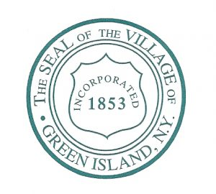
Pursuant to section 97-3 of the Village of Green Island Municipal Code recycling is mandatory.

